MED D - BlueMedicareRx (NEJE) CCR Plan Benefit Overrides in RxClaim

Reminders
Determining if a PBO is Allowed
Adding a PBO
Adding Notes to a PBO in RxClaim
Verifying Who Entered a PBO and Viewing the Audit Trail
Voiding a PBO in RxClaim
Log Activity
Related Documents

Description: This document provides instructions for entering overrides in RxClaim and ensures appropriate application of overrides. When a PBO is appropriate (see specific client CIF) and necessary, you may need to add, update or void a PBO.

We can be assessed fines for lack of documentation or incorrectly entered overrides. Always ensure the override is entered correctly and add notes to every override with an explanation as to why an override was added, updated or voided.

Reminders
- If speaking to the pharmacy directly, direct to the Pharmacy Help Desk (1-800-364-6331). The override should always be entered with the last NDC listed in the most recent rejected retail claim. Always run a mock adjudication (Option 22) in RxClaim with current date to ensure claim pays. If no claim history or mail order, look up NDC number from test claims feature.
- All NEJE EGWP accounts – Contact NEJE Senior Team to complete override.
- You must always check for existing PBOs to ensure you are not duplicating an existing PBO.
- Overrides must be entered on both the primary and secondary for EGWP plans. Refer to:
  - MED D - Senior Team - Plan Benefit Overrides
  - MED D - Plan Benefit Overrides (PBO) - CCR
- RxClaim is preferred when entering any PBOs.

After completing any override, always run a test claim to determine that the claim will pay. In situations where an override is being entered while speaking with a pharmacy representative, a successful test claim must be run prior to advising the pharmacy to process the claim. For more information on how to enter notes on a PBO, refer to the section Adding Notes to a PBO in RxClaim.

Always check to ensure the beneficiary does not have an excess of PBOs on their profile and use your discretion. If you are unsure that a PBO should be entered, or believe that too many have been entered, reach out to the Senior Team for assistance.

If the plan only allows the override one time per medication, beneficiary, dosage, or lifetime, the beneficiary themselves must call for the request.
Top of the Document

Determining if a PBO is Allowed

The first step in addressing any PBO issue, review the appropriate client CIF in order to determine the appropriate action to be taken according to the following table:
If the CIF… | Then…
Allows for specific PBO request or states CCR may enter override | Enter the PBO.  If the CIF indicates pricing, copay, formulary adjustments, or any other financial requirements, the CCR will contact the Senior Team to enter the override.  Example: Override allowed at $0 copay.
DOES NOT allow for specific plan benefit override request | Communicate to the caller that the plan does not allow for the specified override. Beneficiary can purchase the medication out of pocket or look into other options outside the plan. Reference Prescription Financial Assistance for Members for some options.  Example: I apologize, the plan does not allow for the <override being requested>.  Note: When a call is escalated or the situation may warrant an exception for an override that normally says no, a request can be submitted but beneficiary must be advised there is no guarantee that it will be approved. Seniors will use their best judgment on when to request an exception.
States AM Contact to enter a PBO or to contact the Account Management Team | Contact the Senior Team. Refer to MED D - When to Transfer Calls to the Senior Team.

Top of the Document

Adding a PBO

Perform the steps below:
Step | Action
1 | Check the CIF to determine if the beneficiary is allowed the override. Refer to section Determining if a PBO is allowed for details.
2 | Access RxClaim and enter the Member’s ID number. Enter 5 next to the active plan and press Enter.  Result: Display Member Details screen displays.  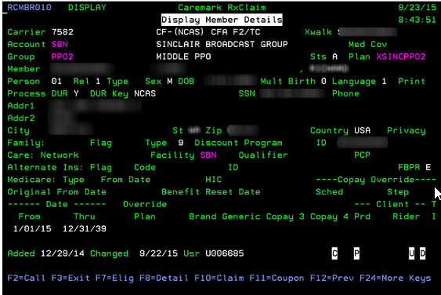
2 | If There is… | Then…
2 | A Rejected Claim | - Press F10 to enter the Claim Details Screen. Enter 5 into the claim you wish to place a PBO for, and press Enter.  - Press F21 (Shift + F9) to enter a PBO by NDC. Some override fields will already be populated. Proceed to step 4.
2 | No Rejected Claim | - Press F16 (Shift +F4) to enter the Prior Authorization Profile Screen.  - Press F6 for Add, then proceed to Step 4.
3 | Complete the fields as indicated below:  Note: Long Term Care PBOs are entered by the Pharmacy Help Desk (1-800-364-6331).  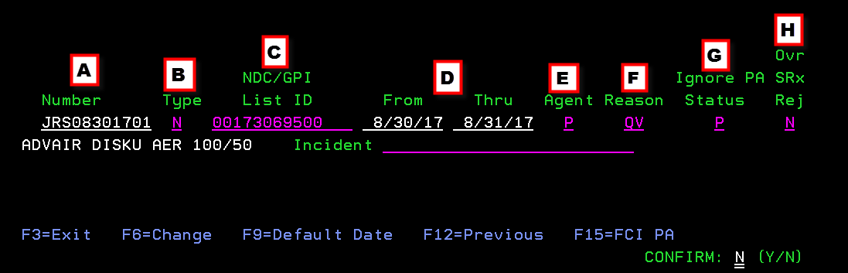  Press Enter and confirm in bottom right corner by selecting Y.  Note: If PBO is built from a rejected claim some information will be prepopulated. Always confirm that prepopulated information is correct and adjust if needed.  EGWP beneficiaries: Enter a "5" on the refill limits line when submitting a PBO.
3 | Illustration | Field | Explanation
3 | A | Number | Type initials, todays date (MMDDYY format) and the number of the PBO that is being input.  Example: JDD01111701
3 | B | Type | Type an N (NDC) or G (GPI).
3 | C | NDC / GPI List ID | Type the NDC from the most recent claim.
3 | D | From and Thru | Type the appropriate from and thru dates (mmddyy format).  Note: To backdate a PBO, adjust these fields.
3 | E | Agent | Type a P.
3 | F | Reason Field | Enter Override Reason codes.  - DC – Dosage Change  - DT – Duplicate Therapy  - LM – Lost Medications  - SM – Stolen Medication  - V – Vacation Meds
3 | G | Ignore PA Status | Type a P.
3 | H | Ovr SRx Rej | Type an N.  Note: If the PBO is for a Specialty Retail lockout the Type should be Y.
4 | Place a 2 on the line next to the override to bring up the Member Prior Auth Override Details screen, then make edits based on the override. Once necessary edits are made press Enter to finalize adjustments.  Result:  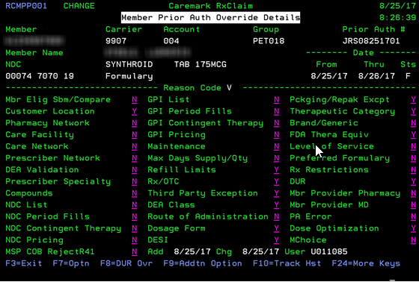
5 | Navigate back to the rejected claim and run a test claim. Refer to MED D - Test Claim for instructions.  After completing any override, always run a test claim to determine that the claim will pay. In situations where an override is being entered while speaking with a pharmacy representative, a successful test claim must be run prior to advising the pharmacy to process the claim.
5 | If Test Claim… |  | Then…
5 | Pays correctly |  | Proceed the next step.
5 | Does NOT process correctly  Example: Claim rejects or wrong copay applies. |  | - Confirm that previous edits were input correctly.  - Run another Test Claim.  If override continues not to work, contact the Senior Team for further assistance.
6 | Add detailed notes to your override via RxClaim. Refer to section Adding Notes to a PBO in RxClaim for instructions.
7 | Instruct the pharmacy to reprocess the claim and verify it paid correctly.
8 | Close and document the call following the current process.

Top of the Document

Adding Notes to a PBO in RxClaim

EVERY override requires notation. Overrides placed on EGWP accounts should both be notated.

Step | Action
1 | From the Main Screen press F16 (Shift+F4) to navigate to the Prior Authorization Profile screen.
2 | Place a 0 on the line next to your override and press Enter.  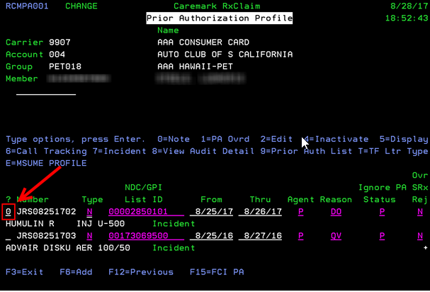
3 | Enter the appropriate notes on the lines provided for your override and press ENTER when complete.  The following items should be included in the notation:  - Pharmacist or pharmacy technician’s name.  - Day supply that the override is maintained for.  - Any specifications surrounding the request.  - Indicate the reason (i.e. Vacation Supply, Lost or Stolen Medication, Formulary Exception, etc.).  - Indicate who approved where applicable, such as client contact.  - Include if entered to fix a temporary problem such as a plan issue and notate what the issue is that it is correcting.  - If edits are made to the PA, indicate what was changed and who changed it.  Tip: You can paste notes from your notepad by using CTRL + V. Right clicking and selecting paste will not work in RxClaim.  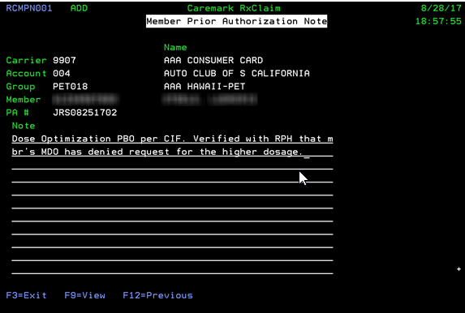  Note: If notes have already been added to the override, you will need to first select F9 to Add before entering your own notes.  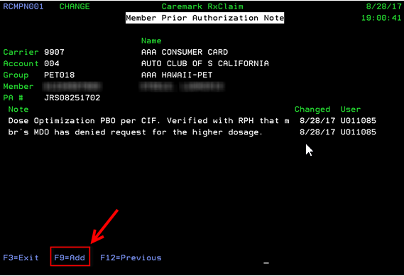

Top of the Document

Verifying Who Entered a PBO and Viewing the Audit Trail

When a PBO is entered using RxClaim, it will not leave an audit trail in PeopleSafe that reflects the name of the person who entered the PBO. In order to locate who entered the PBO perform the steps below:
Step | Action
1 | From the Main Screen press F16 (Shift+F4) to navigate to the Prior Authorization Profile screen.
2 | Place an 8 on the line next to the PBO in question and hit Enter.  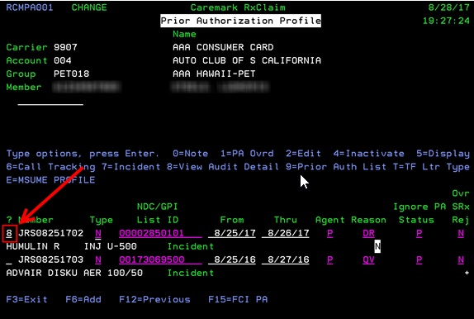  Result:  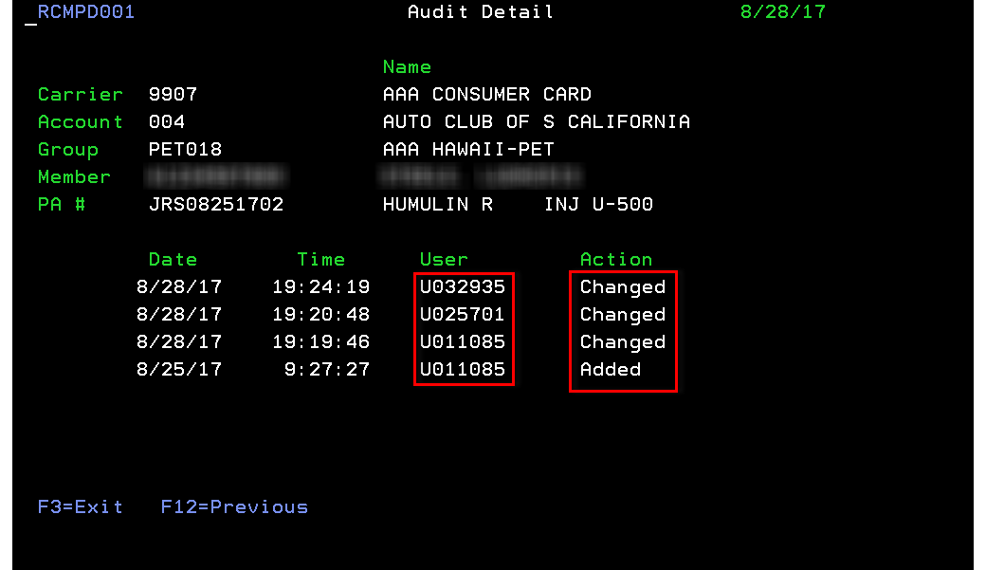  Note: It will not explain what was changed on this page, but some changes will be documented in the notes on the PBO.
3 | Collect the Network ID of the user who entered the override and enter the Network ID on the To line of an email and press CTRL + K to search the global address book. If the representative’s Network ID is loaded into their Outlook profile it will find them this way.  Example:  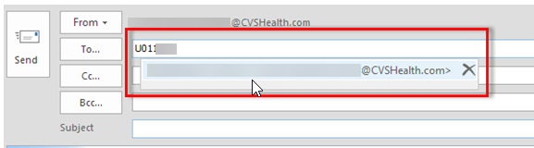

Top of the Document

Voiding a PBO in RxClaim

Occasionally an override needs to be voided. This may include a Prior Authorization or Exception. In order to void a PBO in RxClaim, follow the steps listed below:
Step | Action
1 | Access the beneficiary’s profile in RxClaim.
2 | Access the Prior Authorization Profile screen by pressing F16 (Shift + F4).
3 | Place a 4 on the line next to the PBO you want to void and press Enter.  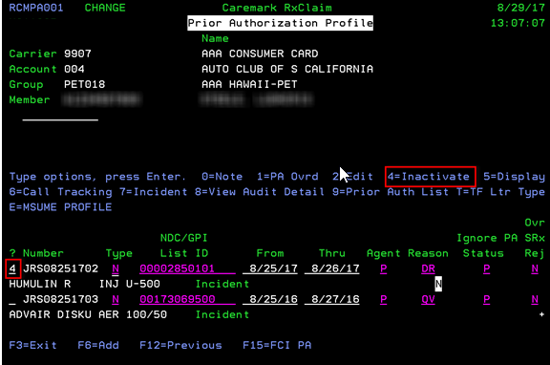
4 | Document the PBO as to why it was voided. Reference Adding Notes to a PBO in RxClaim for instructions.

Top of the Document

Log Activity
1006 – Pln Bene Ovrid (Plan Benefit Override)

Top of the Document

Related Documents
Parent SOP: CALL 0049 Customer Care Internal and External Call Handling

Abbreviations / Definitions: Mail Service/Customer Care Abbreviations, Definitions, and Terms

Top of the Document

Not to Be Reproduced or Disclosed to Others without Prior Written Approval
ELECTRONIC DATA = OFFICIAL VERSION / PAPER COPY = INFORMATIONAL ONLY

